Brazilian Ministry of Health Covid-19 bulletin. No. 17.
Epidemic week 21. 17-23 May
The Ministry of Health, through the Health Surveillance Secretariat (SVS / MS), discloses, weekly, a Bulletin Epidemiological Special (BEE), presenting a more detailed analysis of the profile of the transmission of COVID-19 in Brazil by Federation Unit and Region of Health and also the interpretation of the situation epidemiological.
This edition of the newsletter features, additionally, an epidemiological profile of pregnant women and children and adolescents confirmed for COVID-19 from the information from the Information System Epidemiological Surveillance of the Flu, the SIVEP-Flu.
The dissemination of epidemiological data and structure for coping with COVID-19 in Brazil occurs daily through the site: www.saude.gov.br/coronavirus

PROFILE OF PREGNANT AND CHILDREN AND ADOLESCENTS WITH COVID-19
Data from SIVEP-Gripe were used to determine the epidemiological profile of pregnant women and children and adolescents with Severe Acute Respiratory Syndrome confirmed for COVID-19. To the analyzes were considered the period between SE 08 and 21 of 2020 (between February 16 of May 23 of the year).

Pregnant Women with Severe Acute Respiratory Syndrome by COVID-19
In the period corresponding to SE 08 to 21, 2020, 52,335 hospitalized cases of SARS were reported confirmed for COVID-19, 521 (1.0%) of pregnant women. Of this total, 36 (6.9%) were excluded pregnant women over 50 years old and one (0.2%) pregnant woman with blank age range, totaling 484 pregnant women analyzed. COVID-19 cases in pregnant women were concentrated among epidemiological weeks 15 to 18 (Figure 33).
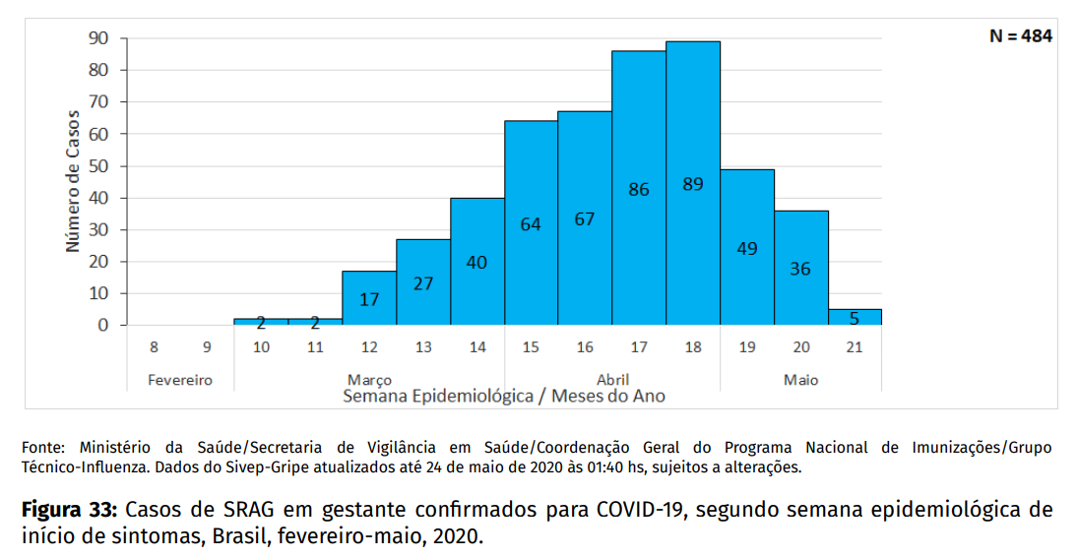
Figure 33: Cases of SARS in pregnant women confirmed for COVID-19, according to the epidemiological week of onset of symptoms, Brazil, February-May, 2020.
The distribution of confirmed cases for COVID-19 in pregnant women, by geographical macroregion and UF of residence occurred as follows: Southeast (n = 258; 53.0%), Northeast (n = 106; 21.9%), North (n = 97; 20.0%), South (n = 19; 3.9%) and Midwest (n = 4; 0.8%). Among the UF, São Paulo had the highest number of pregnant women with the disease (196), followed by Rio de Janeiro (57) and Amazonas (56).
Concerning distribution of deaths in pregnant women affected by COVID-19, the Southeast region concentrated 55.0% (20); and the Northeast 25.0% (9). Deaths were concentrated in the states of Rio de Janeiro (11), São Paulo (8), Amazonas (5) and Ceará (5) (Table 4).

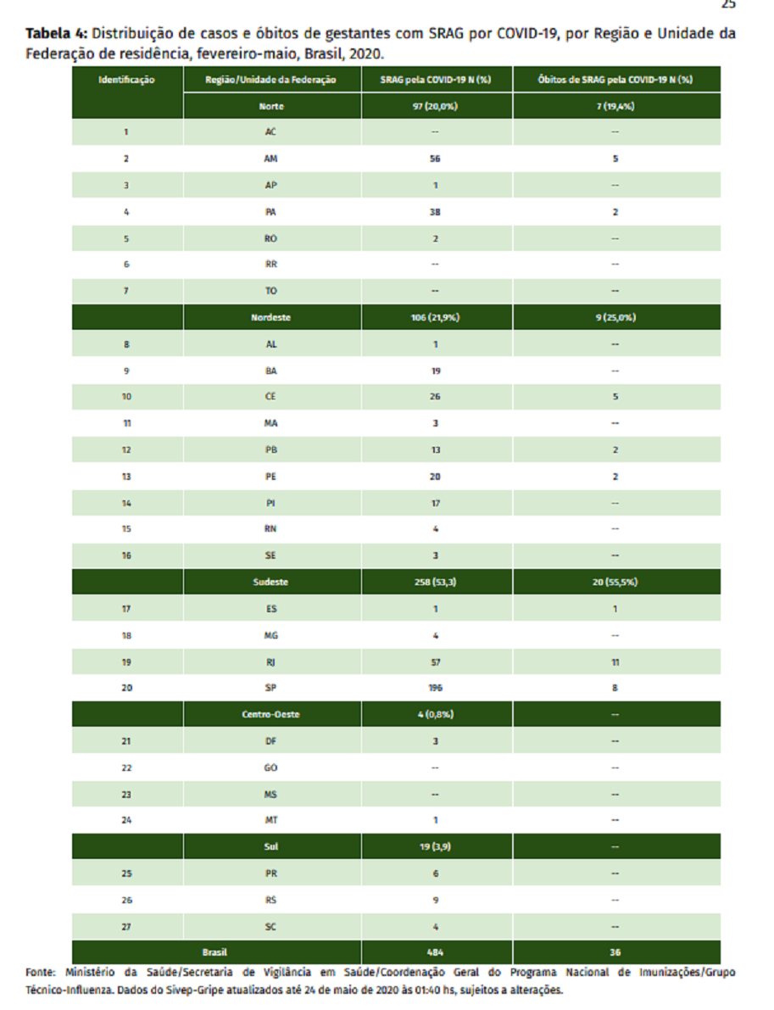

For the analysis of Tables 5, 6 and 7 and Figures 34B and 35A AND 35B, 288 cases were considered with evolution of cure or death, since 196 cases still had the variable “evolution” blank (not filled) or ignored.
It was observed that 86.1% of the pregnant women (n = 248) were in the age group of 20 to 39 years of age, of which 215 (86.7%) evolved to cure and 33 (13.3%) died. The race / brown color it was registered for 107 (42.5%) pregnant women who evolved to cure and 19 (52.8%) who evolved to death.
There were 67 (26.6%) pregnant women with healing outcome and 5 (13.9%) of death with race / white color (Table 5).
Regarding gestational age, 168 (66.7%) of the pregnant women who progressed to cure and 22 (61.1%) who evolved to death were in the third quarter. Among the comorbidities, diabetes mellitus was the most present among pregnant women and occurred in 31 (12.3%) of those who progressed to cure and in 6 (16.7%) who evolved to death (Table 6).
The most frequent signs and symptoms presented by pregnant women were cough (80.6%), fever (72.9%), dyspnoea (62.2%) and respiratory distress (50.8%). In cases that have evolved to cure, the signs and most frequent symptoms were cough (81.8%), fever (73.0%), dyspnoea (60.3%) and respiratory distress (49.2%) and, for those who died, cough (83.3%), fever (72.0%), dyspnea (75.0%) and O2 saturation <95% (66.7%) (Figure 34).
Among the 252 pregnant women with SRAG by COVID-19 who progressed to cure, 43 (17.1%) were admitted to the ICU; 74 (29.4) used ventilatory support, 68 (91.9%) of the non-invasive type and 101 (40.1%) received antiviral medication. Of the total of 36 pregnant women with SRAG by COVID-19 who progressed to death, it was observed that 21 (58.3%) of the pregnant women were admitted to the ICU; 26 (72.2%) used ventilatory support, 21 (80.8%) of which were invasive and 11 (30.6%) were given antiviral (Table 7).
Table 4: Distribution of cases and deaths of pregnant women with SARS by COVID-19, by Region and Unit Residence Federation, February-May, Brazil, 2020.
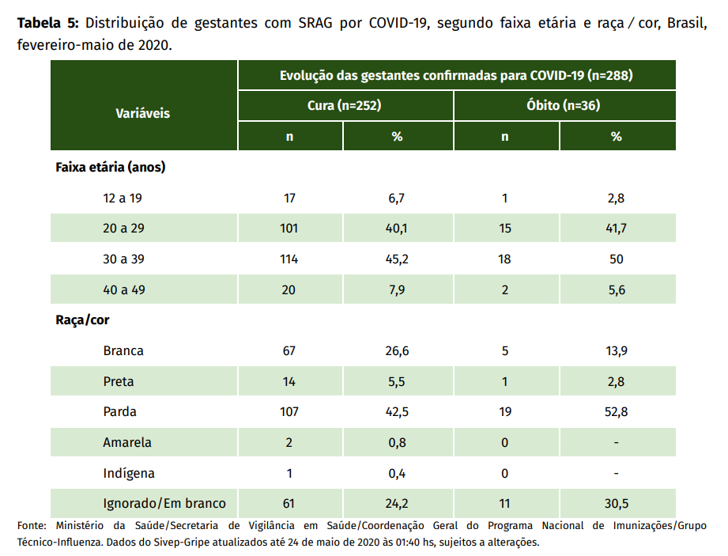
Table 5: Distribution of pregnant women with SARS by COVID-19, according to age and race ∕ color, Brazil, February-May 2020.
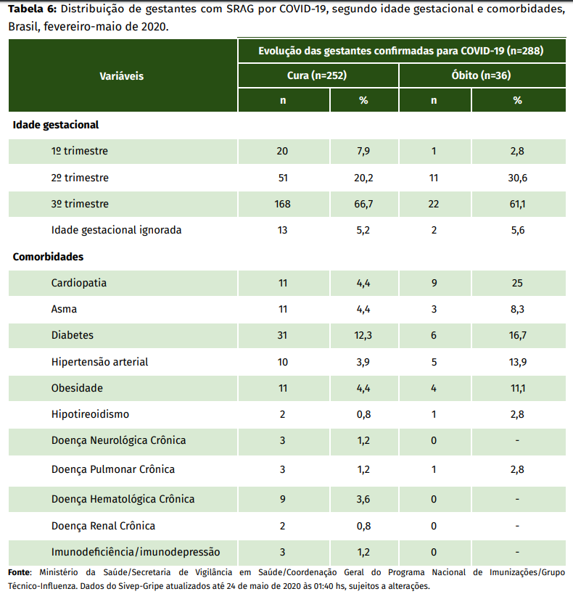
Table 6: Distribution of pregnant women with SARS by COVID-19, according to gestational age and comorbidities, Brazil, February-May 2020.
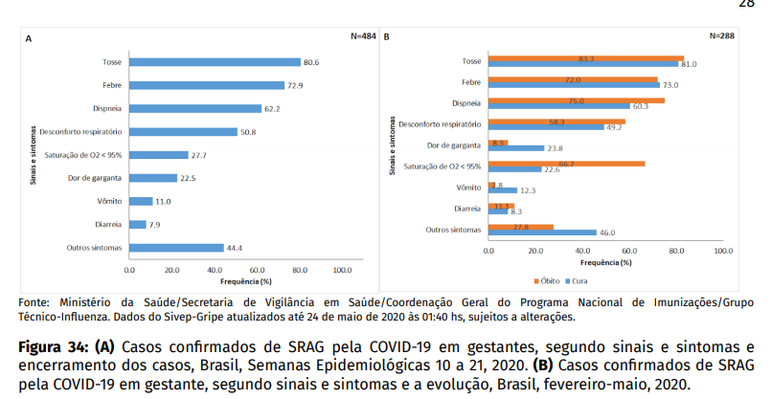
Figure 34: (A) Cases of SRAG confirmed by COVID-19 in pregnant women, according to signs and symptoms and closure of cases, Brazil, Epidemiological Weeks 10 to 21, 2020. (B) Confirmed cases of SARS by COVID-19 in pregnant women, according to signs and symptoms and evolution, Brazil, February-May, 2020.
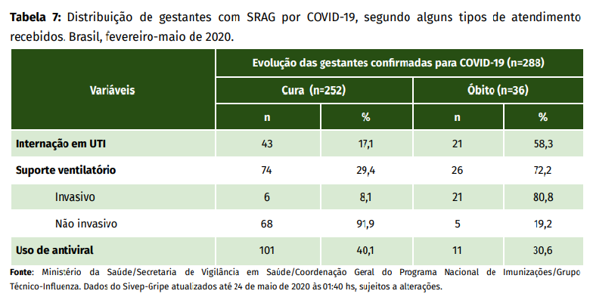
Table 7: Distribution of pregnant women with SARS by COVID-19, according to some types of care received. Brazil, February-May 2020.
Figure 35 shows the analyzes between the symptom onset dates and hospitalization, and between the hospitalization and discharge, according to evolution to cure (discharge) or death. Of the 252 (87.2%) pregnant women with COVID-19 with discharge record, the median time between the onset of signs and symptoms and hospitalization was four days (Q1-Q3: 2-7 days); the median of days between the date of hospitalization and discharge date was 6 days (Q1-Q2: 3-8 days). For the 36 (7.4%) pregnant women with COVID-19 who evolved over death, the median time between symptom onset and hospitalization was 3.5 days (Q1-Q2: 1-6 days), and the median time between the date of hospitalization and death was 8 days (Q1-Q3: 3.8-14.3 days).
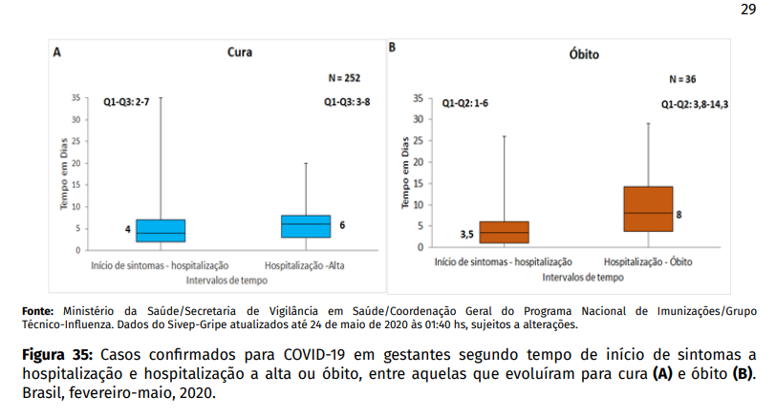
Figure 35: Cases confirmed for COVID-19 in pregnant women according to the onset of symptoms a hospitalization and hospitalization at discharge or death, among those that evolved to cure (A) and death (B). Brazil, February-May, 2020.

